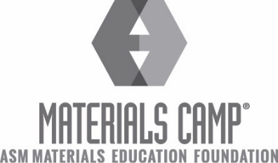
ASM Materials Camp® - Lehigh Valley
July 11-15th, 2022
Lehigh University, Whitaker Lab, Bethlehem, PA

College bound? Think you might want to study engineering or sciences, but not decided on a major? Apply today for an opportunity to be a part of a fun summer camp experience, learning about the Materials Science and Engineering as a field of study.

Commuter Day-Camp held at Whitaker Lab, Lehigh University, July 11th through 15th, 2022 9am – 4pm.

Selected participants will receive:
- an all-expense paid week of fun, hands-on learning about materials science
- daily transportation to and from Lehigh University for Reading-area participants
- instruction at the state-of-the-art facilities at Lehigh University
- meals, (lunch and snacks), provided on location
- an ASM Materials Camp® T-shirt
- a notebook with course notes, diagrams and photographs for you to keep

We are planning another great session, filled with hands-on lab activities, guest speakers from academia and industry. Students who participated in our ASM Materials Camp® at Lehigh University in 2004 – 2019 have told us they had a great time while discovering a field they were not aware of. Several of them have told us they’ve changed their college plans thanks to their ASM Materials Camp® experience.

This is a competitive opportunity for area high school students who:
- Are undecided about their choice of college major
- Are talented in math and science
- Will be entering their junior or senior year in Fall 2022 (high school graduation classes of 2023 and 2024)

Class size is limited to sixteen participants.

For more information, visit www.lvasm.org or contact Ally Fraser at afraser@cartech.com

Application deadline is May 27th, 2022.

ASM International is a non-profit professional society. Its mission is “to benefit the materials community by providing scientific, engineering and technical knowledge and professional development.” The goal of the ASM Materials Education Foundation, a part of ASM International, is “To Excite Young People in Materials Science and Engineering.”

ASM Materials Camp^{® -} Lehigh Valley is made possible through generous sponsorship of
The ASM Materials Education Foundation
Carpenter Technology Corporation
Lehigh University PC Rossin College of Engineering and Applied Science
Materion, Inc.
and by contributions of other area businesses.

ASM Materials Camp® - Lehigh Valley
July 11-15th, 2022
Lehigh University, Whitaker Lab, Bethlehem, PA

COVID-19 Information

Due to the current COVID-19 pandemic, Lehigh University has established the following protocols for in-person programs. Proof of vaccination (+ booster after 5 months) status is required. Masks are optional throughout the duration of the program. Students will be required to fill out a COVID visitor form, which will be provided. For more information, visit Lehigh University’s campus visitors homepage here.

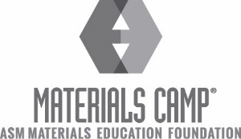 | July 11-15th, 2022  ASM MATERIALS CAMP®  Lehigh Valley Chapter, Lehigh University, Bethlehem, PA

APPLICATION FORM – PLEASE PRINT LEGIBLY IN BLUE OR BLACK INK

Part 1
Student’s Name: Preferred 1st name for name tag:
Address:
(Street or P.O. Box) City State Zip
Email Address (most communication will be sent electronically, if possible):
PRINT NEATLY – DIFFERENTIATE BETWEEN LETTERS AND NUMBERS

Gender: Male Female Date of Birth:

Either Parent’s Name:
Address:
City/State/Zip:
Tel:
(Day) (Evening)
Grade you will be entering next Fall: ____ Junior ____ Senior
Name of High School:
School Address:
Street City State Zip Code
Principal’s Name:
Current school year’s grades on the following subjects (provide grades on most recent grading period):
Science:
Chemistry:
Physics:
Mathematics:
Shirt Size:

Part 2
- Attach a typed personal statement (100 words or more) why you want to be selected to participate in ASM MATERIALS CAMP®. Please include your planned college major (if known)/career plans.
- Included a maximum of two (2) letters of recommendation in signed and sealed envelopes.
- Are you related to an ASM member? Yes No
If yes, please provide name of ASM member and your relationship:

Name of ASM Member Relationship
- Are you related to an employee of Carpenter Technology Corporation? Yes___ No___
If yes, please provide name of your family member and your relationship:

Name of Carpenter Technology Member Relationship
- Are you related to an employee or alum of Lehigh University? Yes___ No___
If yes, please provide name of your family member and your relationship:

Name of Lehigh University Member Relationship

- Attach a copy of most recent report card.
G. How did you learn about Materials Camp?

RETURN COMPLETE APPLICATION PACKET ON OR BEFORE May 27th, 2022 to:
Carpenter Technology Corp.
Attn: Ally Fraser
P.O. Box 14662
Reading, PA 19612

